New Hope Sermon 10 20 21 A Complete Calling

Introduction – The Great Commandment
Have you ever asked God what it means to “love the Lord your God with all your heart and soul and mind and strength?” That is the Biblical imperative in the Old and New Testament for full obedience to the Lord in daily life. (Deut.6: 5, Mk. 12:10). “The second icommandment s like unto it,” Jesus says, “Love your neighbor as yourself.” This is God’s wholistic understanding of our relationship with Him – it encompasses our mind, our will, our emotions and our body. Actually, it was these great commandments that convicted me of sin. As a religious non-Chr istian, I couldn’t accept the Biblical understanding that I was sinful through and through until God brought this standard to me and convicted me through that little three letter word “all!”

But, how do we live this great commandment in practical life?

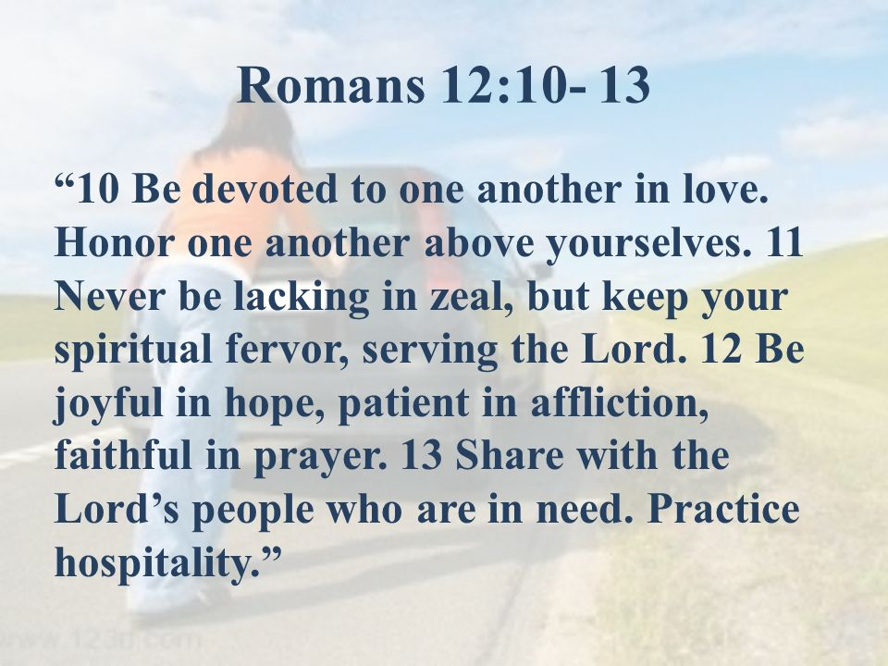
This past weekend, God reenforced for me an answer through Romans 12:10-13. To the left is the NIV translation.

The Message puts it in contemporary language:
⁹⁻¹⁰ Love from the center of who you are; don’t fake it. Run for dear life from evil; hold on for dear life to good. Be good friends who love deeply; practice playing second fiddle.
¹¹⁻¹³ Don’t burn out; keep yourselves fueled and aflame. Be alert servants of the Master, cheerfully expectant. Don’t quit in hard times; pray all the harder. Help needy Christians; be inventive in hospitality.

And the Passion amplifies the meaning by including the Aramaic:
¹⁰ Be devoted to tenderly loving your fellow believers as members of one family. Try to outdo yourselves in respect and honor of one another. ¹¹ Be enthusiastic to serve the Lord, keeping your passion toward him boiling hot! Radiate with the glow of the Holy Spirit and let him fill you with excitement as you serve him.¹² Let this hope burst forth within you, releasing a continual joy. Don’t give up in a time of trouble,^{[a]} (rendered in Aramaic “ “Bear your afflictions bravely”); but commune with God at all times.¹³ Take a constant interest in the needs of God’s beloved people and respond by helping them. And eagerly welcome people as guests into your home.

So let me challenge you as God challenged me this week to live out this complete calling as one who loves and serves God wholeheartedly. It is a “complete calling” because it encompasses our mind (understanding God’s purposes), our will (being obedient as we choose what God wants and by His strength endure affliction and rejoice in hope), our emotions (as we grow in the what it means to be devoted to each other) and our relationships with God and all people.

A Complete Calling
Practical love
This group of admonitions for believers starts with our choice to “be devoted to one another in love.” v. 10 No surprise since Jesus told the disciples that it was to be their love for one another that would show the world they are His disciples. (Jn. 13:34-35, 15:12,17).

But, that love cannot be sustained in its breadth on an emotional level. “To be devoted” is really a matter of the will – a daily choice in the midst of our differences, our conflicts, and all our priorities. Devoted implies an unwavering faithfulness. The New Collegiate Dictionary defines devoted as “to give up oneself or one’s time, energy to some purpose, activity or person, to be loyal.” It is the kind of love described in I Corinthians 13:4-7:
Love is patient and kind. Love is not jealous or boastful or proud ⁵ or rude. It does not demand its own way. It is not irritable, and it keeps no record of being wronged. ⁶ It does not rejoice about injustice but rejoices whenever the truth wins out. ⁷ Love never gives up, never loses faith, is always hopeful, and endures through every circumstance. NLT NIV translates v. 7 as It always protects, always trusts, always hopes, always perseveres. Bearing, believing, hoping, enduring. That’s basically hanging in there with another despite the differences in personality, doctrines, lifestyle, culture and priorities. In the vernacular, it is “having another’s back.”

Verse 11 also says this kind of love is proven in treating another with respect and honor – no shaming, no gossip, no overbearing actions nor critical words that tear down, diminish nor oppress another. Instead, this love deliberately chooses words of grace that build another up (Eph.4:29 – “And never let ugly or hateful words come from your mouth, but instead let your words become beautiful gifts^{[a]} that encourage others; do this by speaking words of grace to help them.” (Passion).

Verse 13 also gives other practical guidelines for showing love: “Share with those in need and practice hospitality.” It has been painful to not be able to fulfill that last mandate of practicing hospitality in our current shared rental home with our roommates’ great restrictions against anyone coming in or sharing food inside. But we have found since we arrived back in Wheaton that so many people have been sharing in our need to refurnish our home and restock items we gave away in our move south. We’ve been given furniture, appliances, clothes, money, and people’s time and energy. Several come weekly and take us to the stores or doctors or on small outings since we still do not have a caregiver. In fact, Marti has discovered an amazing resource in her community (it is not available in our Wheaton north community) called Buy Nothing Northern Naperville. These generous folk actually give away items! So thanks to Marti I estimate now that ¼ of all our household needs have been supplied by BNNN. Very practical love that serves.

Fervor and zeal in one’s Christian life
The other mandates that describe our calling in the Rom. 12 passage have to do with passion and zeal:
^{11 “}Never be lacking in zeal, but keep your spiritual fervor, serving the Lord.” NIV The Message translates this as: “Don’t burn out; keep yourselves fueled and aflame.” Passion says: “Be enthusiastic to serve the Lord, keeping your passion toward him boiling hot! Radiate with the glow of the Holy Spirit.”

Contrast this spirit with the lukewarmness God condemned in Laodecia:
¹⁵ I know all that you do, and I know that you are neither frozen in apathy nor fervent with passion.^{[a]} How I wish you were either one or the other! ¹⁶ But because you are neither cold nor hot, but lukewarm, I am about to spit you from my mouth.^{[b]} ¹⁷ For you claim, “I’m rich and getting richer—I don’t need a thing.”^{[c]} Yet you are clueless that you’re miserable, poor, blind, barren, and naked! ¹⁸ So I counsel you to purchase gold^{[d]} perfected by fire, so that you can be truly rich. Purchase a white garment to cover and clothe your shameful Adam-nakedness.^{[e]} Purchase eye salve to be placed over your eyes so that you can truly see. (Rev. 3:15-18 Passion)

In the book I am reviewing this week (The Lord is my Counsel by Marion Wade), Wade speaks of the “creeping indifference “ he has witnessed over the years of people toward the Lord and toward the Bible. The Laodecian-style lukewarmness. He says, “Ýou can tell that the indifference has started creeping when you experience a change in your motivation from outgoing to incoming…Significantly, the Bible stresses this point of outgoing wholeheartedness repeatedly. We are instructed, for instance, to love the Lord our God with all our heart, all our soul and all our might. Clearly then, there is no room for halfhearted indifference in this area.” (Prentice Hall Press, 1966, p,32)

From Paul’s perspective, a Christian’s (and church’s) zeal is manifested in joyfulness in hope, patience in affliction and fervency in prayer. It is manifested in our self-discipline to be faithful in time with the Lord each day and response to the Spirit’s prompts for fervent prayer, acts of service for others, and the ability to stay strong through affliction. This Complete Calling encompasses so many aspects of our entire life – our will, our emotions, our words, our actions, our incarnation of the Lord. I am going to keep referring to it all fall and hope you will do so too. That way we can help each other stay on the higher path and keep our zeal and spiritual fervor wholehearted.

For His glory and by the power of His Spirit. Amen.

Dr. Mary Lou Codman-Wilson, PhD.
Pastor New Hope Global Fellowship, 10 20 21

